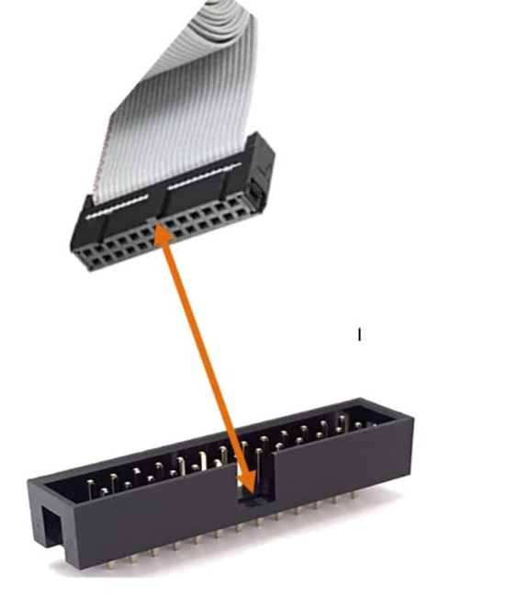

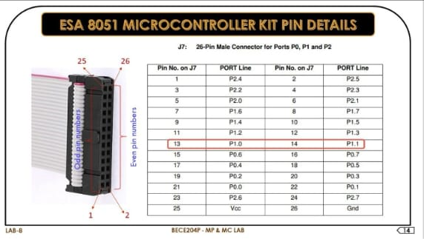

1. Code
2. Options for target
2.1 check device
2.2 target - 11.0592, check three boxes
2.3 output - hex file check
2.4 debug use keil 51 driver
Settings - com port check device manager
Bad rate 9600 fixed ok ok

Rebuild all
Reset the kit
Start debug
Run
Reset the kit
Stop debugging

PROGRAMMING:

Program 2: Write an 8051 C program to toggle all the bits of p1 continuously.
PROGRAM :
#include<reg51.h>
void delay_ms(unsigned int j); //Delay function declaration

void main(void)
{
P1=0xFF; //configure Port 1 As output port.
while(1) //Perform repeat continously (toggle P1 Bits)
{
P1=0xAA; //send data to port 1.
delay_ms(1000); //wait some time (delay=1sec).
P1=0x55; //send another data for toggle the bits.
delay_ms(1000); //wait some time (delay=1sec).
}
}

void delay_ms(unsigned int j) // DELAY = 1ms
{
unsigned int i;
for(;j>0;j--)
{
for(i=250;i>0;i--)
{}
for(i=250;i>0;i--)
{}

}
}

Program 3: Write an 8051 program to toggle all bits of PORT 1 50000times.
PROGRAM :
#include<reg51.h>
void delay_ms(unsigned int j); //Delay function declaration

void main(void)
{
unsigned int z; //initialize varible..
P1=0xFF; //configure Port 1 As output port.
for(z=50000;z>0;z--) //(toggle P1 Bits 50000times
{
P1=0xAA; //send data to port 1.
delay_ms(1000); //wait some time (delay=1sec).
P1=0x55; //send another data for toggle the bits.
delay_ms(1000); //wait some time (delay=1sec).
}
}

void delay_ms(unsigned int j) // DELAY = 1ms
{
unsigned int i;
for(;j>0;j--)
{
for(i=250;i>0;i--)
{}
for(i=250;i>0;i--)
{}

}
}

Program 4: Write an 8051 program to toggle one bits of PORT 1 50000times.
PROGRAM :
#include<reg51.h>
void delay_ms(unsigned int j); //Delay function declaration
sbit toggle=P1^0; //define name for Port bit

void main(void)
{
unsigned int z; //initialize varible..
P1=0xFF;
P1=0x00; //configure Port 1 As output port.
for(z=50000;z>0;z--) //(toggle P1 Bits 50000times
{
toggle=0; //send data to port 1 pin 0.
delay_ms(1000); //wait some time (delay=1sec).
toggle=1; //send another data for toggle the bits.
delay_ms(1000); //wait some time (delay=1sec).
}
}

void delay_ms(unsigned int j) // DELAY = 1ms
{
unsigned int i;
for(;j>0;j--)
{
for(i=250;i>0;i--)
{}
for(i=250;i>0;i--)
{}

}
}

Program 5: Write an 8051 program to toggle one bits of PORT 1 continuously with delay of 250ms.
PROGRAM :
#include<reg51.h>
void delay_ms(unsigned int j); //Delay function declaration
sbit toggle=P1^0; //define name for Port bit

void main(void)
{
P1=0xFF;
P1=0x00; //configure Port 1 As output port.
while(1) //toggle P1 Bits continously.
{
toggle=0; //send data to port 1 pin 0.
delay_ms(250); //wait some time (delay=250msec).
toggle=1; //send another data for toggle the bits.
delay_ms(250); //wait some time (delay=250msec).
}
}

void delay_ms(unsigned int j) // DELAY = 1ms
{
unsigned int i;
for(;j>0;j--)
{
for(i=250;i>0;i--)
{}
for(i=250;i>0;i--)
{}

}
}

